**Assignment 1: Automated Instance Management Using AWS Lambda and Boto3**

**Objective:** In this assignment, you will gain hands-on experience with AWS Lambda and Boto3, Amazon's SDK for Python. You will create a Lambda function that will automatically manage EC2 instances based on their tags.

**Task:** You're tasked to automate the stopping and starting of EC2 instances based on tags.

1. **Setup:**

- Create two EC2 instances.

- Tag one of them as `Auto-Stop` and the other as `Auto-Start`.

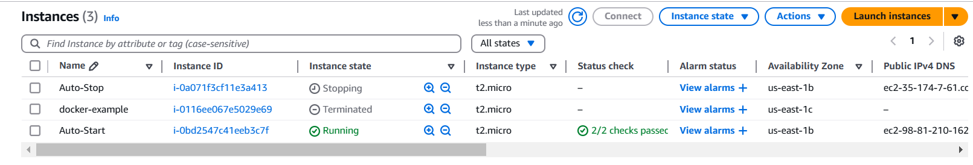

**2. Lambda IAM Role:**

- In the IAM dashboard, create a new role for Lambda.

- Attach the `AmazonEC2FullAccess` policy to this role.

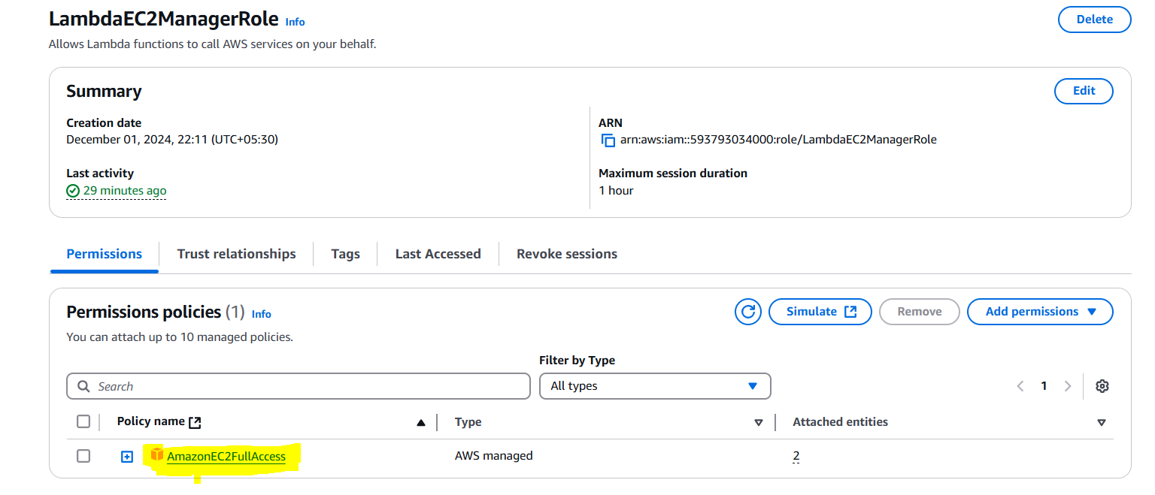

**3. Lambda Funcion Creation and Testing -**

- As the tag defined the function will stop the instance and start the instance respectively.

- Increase the timeout time to run without timeout exception.

